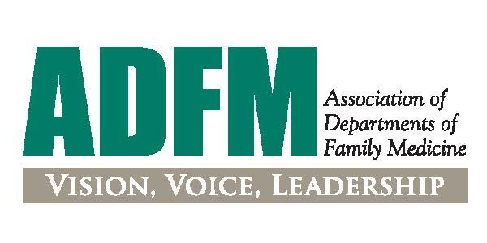

ADFM Leadership Education for Academic Development and Success (LEADS) Fellowship Nominator Form

We are currently seeking applications for our 2025-2026 ADFM LEADS Fellowship Program.

The ADFM LEADS Fellowship Program is designed for those who aspire to become a senior leader in academic medicine or an academically affiliated health system (e.g. department chair, service line leader, associate dean, vice chair) - and for those who are interested in learning more about whether these positions would be a good fit.

The goal of the fellowship is to train pluripotent leaders with the skills/understanding of a high-level leadership position and would also be competitive for other leadership positions beyond the scope of their current role within an academic medical center or an academic-affiliated health system. It is complementary to other programs, while offering unique training, with an intent to provide high-level leaders for the discipline.

Key design features include weekly Zoom meetings (for interactive webinars, journal club, and project check-ins), two in-depth, in-person workshops; an individually designed project emphasizing an area of professional development; two ADFM national meetings; and mentoring by senior faculty members. The intensive nature of the fellowship supports relationship building and peer mentoring among the fellows.

For more details on the program overview, eligibility requirements and fees - please visit our site: https://adfm.org/programs/leads-fellowship/ or reach out to JoBeth Hamon (jhamon@adfm.org).

All materials are due by June 10, 2024.

The nominator form must be completed by someone other than the candidate (within or outside the candidate's institution - may be a candidate's supervisor or not).

Background information
- First name

- Last name

- Institution

- Candidate's name

Nominator's statements

- Why are you nominating this candidate?

- What new knowledge/skills would you want this candidate to learn during their fellowship year?

- How will you work with and mentor your candidate during and after the fellowship?

- What are the candidate's strengths and weaknesses as they relate to their potential as an institutional leader?

- What is your frank evaluation of the candidate's potential for leadership?

- What formal or informal leadership roles do you anticipate this candidate assuming in the next 3-5 years? How will you support them in this endeavor?
- Your relationship to this candidate.

- Additional information you would like to share about this candidate.

