National Research Strategy for Family Medicine: 2024-2030
PROPOSED VISION
Family Medicine will be a discipline that distinctively conducts research that is patient, family, and community centered, enhances health promotion, improves care for chronic diseases and advances healthcare delivery, while including cross-cutting themes of health equity, technology, and team science
RECOMMENDED STRATEGIC PRIORITIES
Pathways / Mentorship   | Funding & Advocacy  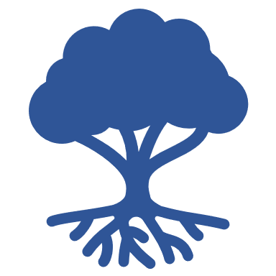 | Infrastructure  
DRAFT GOALS
Grow the family medicine research workforce by expanding pathways and strengthening mentorship | Increase funding for family medicine research and advocate for enhanced health policy and support | Build a national infrastructure for organizing and optimizing family medicine research opportunities
PRELIMINARY OBJECTIVES
A1: Maintain, promote and contribute to a database of family medicine research programs to connect learners to research training opportunities  A2: Enhance and grow pathways to participate in family medicine research for  - medical students (e.g. expanding MD/PhD programs)  - residents (e.g. creating additional degree programs and fellowships)  - and family physicians (e.g. offering training opportunities)  A3: Create structured faculty mentorship experiences inside and outside home institutions  A4: Normalize a team science approach by developing cross-disciplinary partnerships with PhDs and interprofessional groups, and by strengthening partnerships between PhDs and family medicine physicians  A5: Promote a “culture of curiosity” among medical students and family medicine residency programs to ensure the workforce is well-equipped to critically analyze evidence | B1: Define and promote the value of family medicine research  B2: Align advocacy efforts with the 2021 NASEM report and forthcoming action plan to build momentum and increase support for family medicine research, including the creation of an NIH Center for Family Medicine  B3: Continue advocacy to increase funding for AHRQ National Center for Excellence in Primary Care Research and support efforts to direct other sources of funding to primary care research (e.g. PCORI, CDC, and HRSA)  B4: Advocate for increased funding for Departments of Family Medicine from internal university leadership  B5: Identify and promote best practices for chairs to support and fund research participation within their departments and universities | C1: Create partnerships and align the discipline with future advancements in healthcare delivery to be on the forefront of new research opportunities  C2: Utilize a repository of clinical data to answer key questions in primary care  C3: Increase accessible and integrated research models that produce clinically applicable research and evidence-base (e.g. optimize PBRNs, communities of practice, and consider other types of networks such as geographic and content networks)  C4: Leverage Clinical and Translational Science Awards (CTSA) networks and create Centers of Excellence to increase family medicine research within institutions  C5: Design and utilize distinctive methodology such as pragmatic trials, participatory methods, implementation research and dissemination, big data analytics and machine learning

Notes for Implementation Plan

Communication
Goal: Ensure stakeholders are knowledgeable and regularly updated about implementation of the family medicine research strategy

Potential Action Steps:
- Develop a comprehensive communication plan that articulates the family medicine research strategy and includes timely, relevant and targeted updates to stakeholders through multiple channels (email, newsletters, dashboards, etc.)
- Utilize partnering organizations to widely disseminate information and updates regarding the family medicine research strategy
- FMLC organizations adopt and integrate the strategic plan into their work

