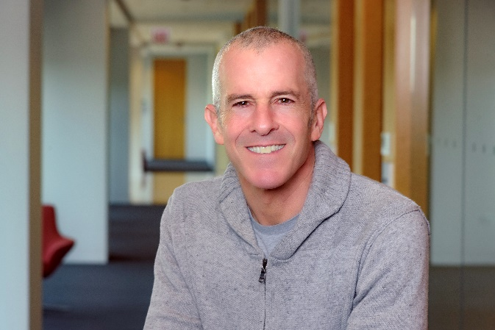**Daniel Blaney-Koen, JD**, is a senior attorney with the American Medical Association Advocacy Resource Center (ARC), the state government affairs group at the AMA.

Daniel has held several roles at the AMA, including serving as a public information officer, policy analyst and speechwriter. Daniel’s portfolio includes drug-related overdose prevention and treatment; treatment for patients with pain; and broad harm reduction efforts. Daniel also works on issues to support physicians and other health care professionals seeking care for mental health and wellness concerns; and he covers other pharmaceutical issues and related insurance market reforms.

Prior to joining the AMA in 1999, Daniel earned his Master of Fine Arts in Poetry from Colorado State University, and his Bachelor's Degree from the University of Arizona. He earned his law degree from the Loyola University Chicago School of Law. Daniel, his wife, two young sons and daughter live in Chicago, Illinois.