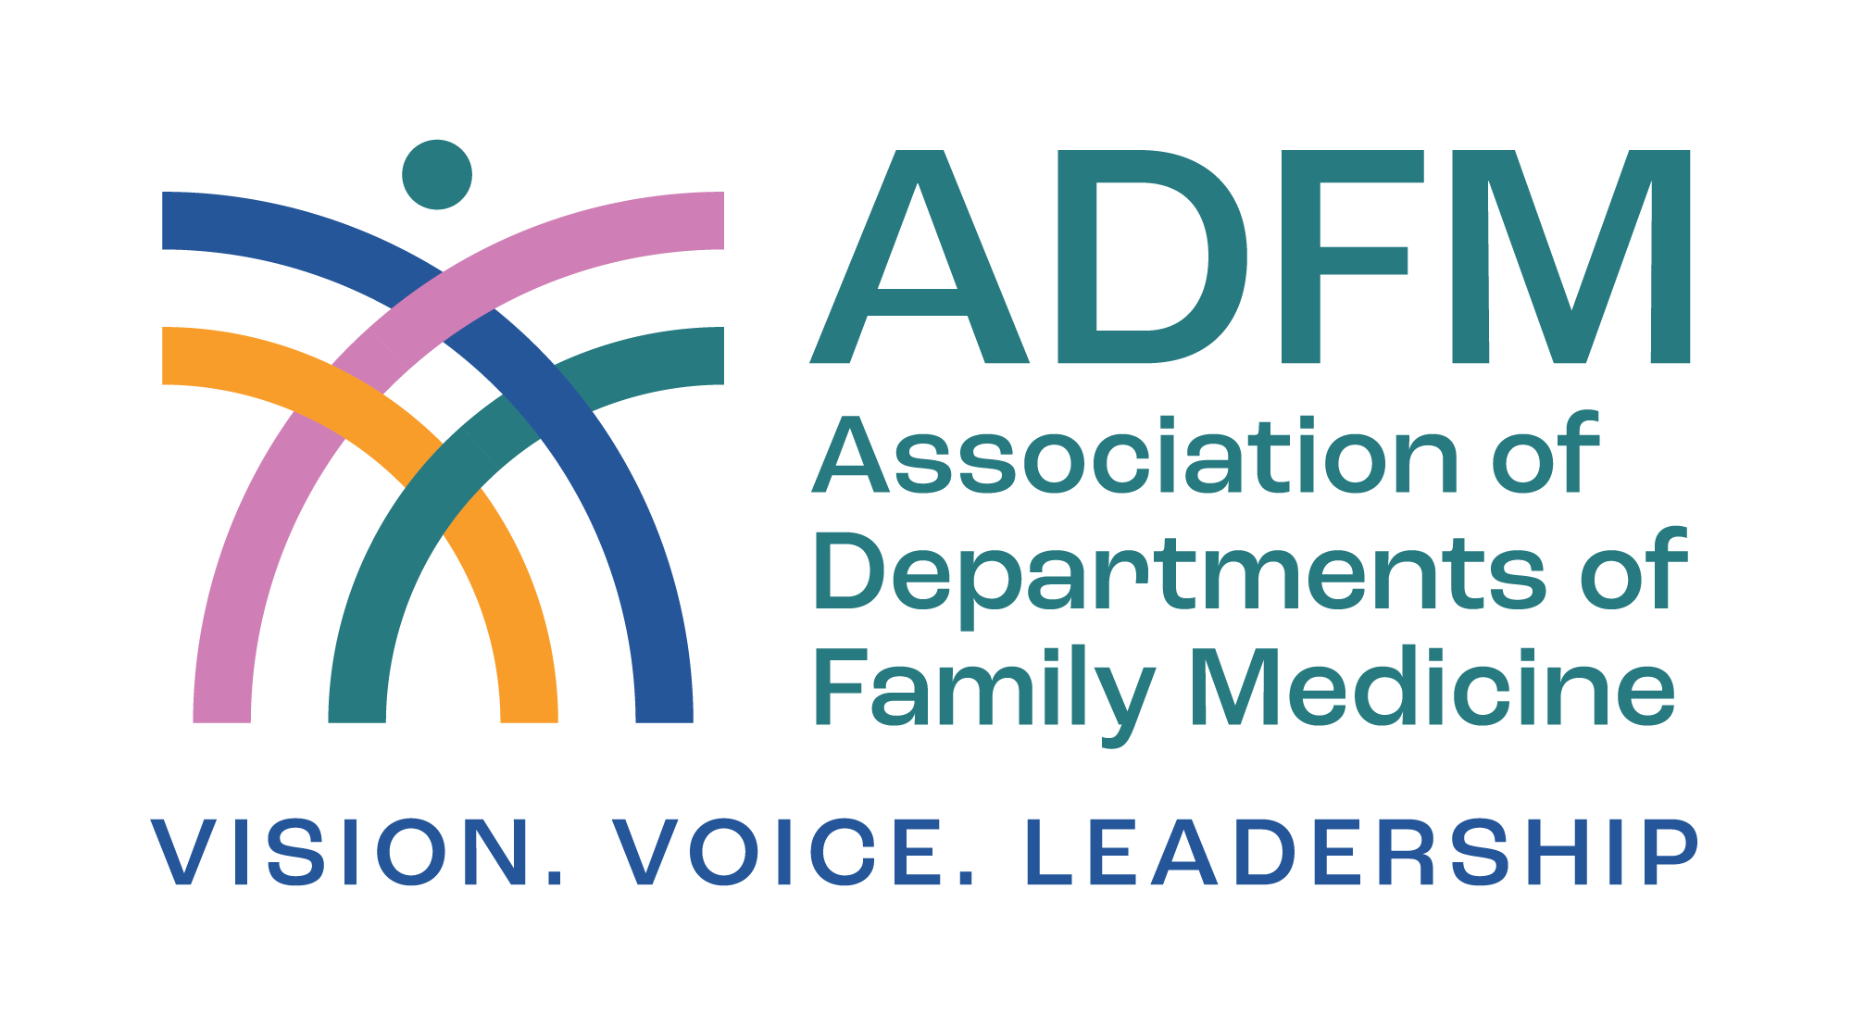

ADFM Leadership Education for Academic Development and Success (LEADS) Fellowship Nominator Form

We are currently seeking applications for our 2027-2028 ADFM LEADS Fellowship Program.

The ADFM LEADS Fellowship Program is designed for those who aspire to become a senior leader in academic medicine or an academically affiliated health system (e.g. department chair, service line leader, associate dean, vice chair) - and for those who are interested in learning more about whether these positions would be a good fit.

The goal of the fellowship is to train pluripotent leaders with the skills/understanding of a high-level leadership position and would also be competitive for other leadership positions beyond the scope of their current role within an academic medical center or an academic-affiliated health system. It is complementary to other programs, while offering unique training, with an intent to provide high-level leaders for the discipline.

Key design features include weekly Zoom meetings (for interactive webinars, journal club, and project check-ins), two in-depth, in-person workshops; an individually designed project emphasizing an area of professional development; two ADFM national meetings; and mentoring by senior faculty members. The intensive nature of the fellowship supports relationship building and peer mentoring among the fellows.

The timeline for the 2027-2028 cohort year is:

- February 22-26, 2027 | ADFM Annual Conference & LEADS Workshop | Salt Lake City, UT

- Starting in March 2027 - Start weekly Wednesday virtual meetings at 10am PT/12pm CT/1pm ET

- July 15-17, 2027 | LEADS Workshop | In-Person, Denver, CO

- November 13-17, 2027 | LEADS Workshop in conjunction with NAPCRG Annual Meeting | Vancouver, British Columbia, Canada

- February 14-18, 2028 | ADFM Annual Conference & LEADS Workshop | Austin, TX

For more details on the program overview, eligibility requirements and fees - please visit our site: https://adfm.org/programs/leads-fellowship/ or reach out to JoBeth Hamon (jhamon@adfm.org).

All materials are due by June 8, 2026.

The nominator form must be completed by someone other than the candidate (within or outside the candidate's institution - may be a candidate's supervisor or not).

Background information
- First name

- Last name

- Institution

- Candidate's name

Nominator's statements

- Why are you nominating this candidate?

- What new knowledge/skills would you want this candidate to learn during their fellowship year?

- How will you work with and mentor your candidate during and after the fellowship?

- What are the candidate's strengths as they relate to their potential as an institutional leader?

- 5. What are some areas of opportunities for professional development?

- What formal or informal leadership roles do you anticipate this candidate assuming in the next 3-5 years?
- Your relationship to this candidate.

- Additional information you would like to share about this candidate.

